Name ________________________ Today’s Date _______________ Test Date _______________ Hour___
Chapters 4, 5, and 6 Study Guide
The Great Encounter, Passing through the Great Basin, and Their Faces Towards Hope
Notes
Age of Exploration (pg. 68-69) Chapter 4
1. What was "The Great Encounter?" What was the result of Christopher Columbus’s voyages to the Americas?
Was it great (good, beneficial) for everyone? Explain in 2-4 sentences.

2. How did the Spanish learn about the Southwestern part of what is now the United States?

3. Who was Juan Rivera and what was he looking for? _____________________________________________
4. What were missions and presidios and how did the Spanish use them in the areas they controlled?
Mission: Presidio:

Use: Use:

5. Describe three things that Spanish priests would have taught Native Americans at a mission.
1) 2) 3)

The Utes Meet Father Escalante (pg. 70-71)
6. What were Fathers Dominguez and Escalante looking for? _______________________________________
7. Who were Silvestre and Joaquin? (The teenagers, not the priests!)

8. What did Bernardo de Miera y Pacheco make for the expedition? _________________________________
9. Was their expedition a success? Why or why not? Support your answer with evidence.

Mountain Men & Rendezvous (pg. 72-73)
10. Why did the Mountain Men come to Utah? Provide at least three reasons why they came out West.

11. What happened at a rendezvous? Why were they important to the Mountain Men?

12. How did Cache Valley get its name? ________________________________________________________
Indian-Trapper Conflict (pg. 74)
13. Why did the Mountain Men (Trappers) sometimes have conflicts with Native American tribes? Describe at least three problems that caused conflicts between them.

Trapping Companies (pg. 74)
14. What were some of the benefits and problems of being an independent trapper or a company trapper?
Independent Company
Benefits Problems Benefits Problems

Utah’s Mountain Men (pg. 75-77)
Write two interesting facts about each of these Mountaineers. Each one should be different than the others.
15. Jedediah Smith
1)

2)

16. Peter Skene Ogden
1)

2)

17. Jim Bridger
1)

2)

18. James Beckwourth
1)

2)

19. Etienne Provost
1)

2)

The Old Spanish Trail & Walkara (pg. 78)
20. What was the purpose of the Old Spanish Trail? Who used it and why? How did it change the lifestyles of the Indian tribes who lived in Utah? Why was it longer than it needed to be?

21. How did the horse change Native American’s lifestyle in good and bad ways? Explain both sides!!!

The End of an Era (pg. 79)
22. What ended the trapping lifestyle of the mountain men? Describe at least two reasons and support with evidence.

23. What were three things that the Mountain Men did after the trapping era ended?
1) 2) 3)

24. What were some of the outcomes of the cultural exchange between Native Americans and the explorers? How did both groups change? Benefits and problems? Describe at least three issues.

Manifest Destiny (pg. 84) Chapter 5
25. What is “Manifest Destiny”? Explain in 2-3 sentences what it is and how it was done. Who benefitted from it, who suffered because of it? Explain why.

26. Why were people moving from the East to the West? (3 reasons- book and video notes)

Bidwell-Bartleson Party 1841 (pg. 84-85)
27. The first known wagon train to cross northern Utah belonged to the _______________________________
28. What were some (2-3) of the challenges they faced moving west?

John C. Fremont (pg. 86-87)
29. What was the nickname of John C. Fremont? ____________________________
30. What was the purpose of his 1853 expedition?

31. What were some (3-4) of Fremont’s contributions?

Pioneer Companies Follow Hastings Cutoff (pg. 88-89)
32. What were the two trails called that people were using to travel west from the United States? (map pg. 88)
- 2)
33. What were the names of the forts build to supply pioneers on their journey? (map pg. 88)
1) 2) 3)
34. Who was Lansford Hastings and what did he do? What was the Hastings Cutoff?

Describe each of these pioneer groups with two unique details or facts about each of them.
35. Bryant Party (1846)
1)

2)

36. Harlan-Young Group (1846)
1)

2)

37. Lienhard Party (1846)
1)

2)

Donner-Reed Party 1846 (pg. 90-91)
38. Describe what happened to the Donner-Reed party. What were some of the reasons the Donner-Reed party met with disaster? (3-4 reasons)

39. Who was Patty Reed and what did she do? (Read page 95)

Miles Goodyear (pg. 92)
40. What role did Miles Goodyear have in Hastings Cutoff, and how did this contribute to the future settlement of Ogden? (at least 2 sentences)

Changing Boundaries of the United States (pg. 93)
41. Which countries (3) claimed the land in the West? What country owned Utah during this time?

A Journey for Religious Freedom (pg. 98-99) Chapter 6
42. What was the Great Awakening? How did it affect the United States? Describe 2-3 changes that occurred in American society during this time.

43. Who was the first leader of the Church of Jesus Christ of Latter-day Saints? _______________________

44. Explain the origin of the two common nicknames given to the Church of Jesus Christ of Latter-day Saints.
LDS Mormons

45. Why did the Mormons move from place to place in their early history? Describe some of the events and issues that led to this movement.

Nauvoo, Illinois (pg. 100-103)
46. Describe the reasons why there were misunderstandings and conflicts between early LDS church members and their neighbors. (at least four reasons for each side’s views)
LDS Point of View Non-LDS Point of View
- -

- -

- -

- -

Moving West—A Difficult Task (pg. 104-105)
47. Why was the move west difficult?

48. Who was Brigham Young and what did he do in this chapter? Describe some of the ways Brigham Young helped prepare the Mormons for the move west. (2-3 details)

49. What was the Mormon Battalion? Why did Mormons join the Mormon Battalion?

The Advance Pioneer Company (pg. 106-107)
50. What was the purpose of the advance pioneer company?

Into the Valley (pg. 108-109)
51. Describe the events that took place when the Mormons entered the valley of the Great Salt Lake.

52. On what date did the advance pioneer company enter the Salt Lake valley? ________________
Later Pioneer Companies (pg. 110-114)
53. What was daily life like for the pioneers? (3-4 details)

54. What kinds of difficulties did travelers face on the trail? (3-4 details)

Fact or Opinion (In class activity and worksheet)
55. What is a fact?

56. What is an opinion?

57. What is a reason judgement?

58. Why is it important to be able to tell fact from opinion, especially when studying history?

Reading Test
You will need to be able to read a map of the routes of the Mountain Men in Utah, & a map of Hastings Cutoff
Vocabulary:
word: barter |  | My Understanding: 4 3 2 1
Definition: |  | Draw a picture of it:
Sentence:
Synonym/Example: | Antonym/Non-Example:

word: cache |  | My Understanding: 4 3 2 1
Definition: |  | Draw a picture of it:
Sentence:
Synonym/Example: | Antonym/Non-Example:

word: colonize |  | My Understanding: 4 3 2 1
Definition: |  | Draw a picture of it:
Sentence:
Synonym/Example: | Antonym/Non-Example:

word: convert |  | My Understanding: 4 3 2 1
Definition: |  | Draw a picture of it:
Sentence:
Synonym/Example: | Antonym/Non-Example:
Bonus Questions
1. What was Columbus looking for when he “discovered” America?

2. Which Spanish explorer was looking for the Cities of Gold?

word: ethnocentricity |  | My Understanding: 4 3 2 1
Definition: |  | Draw a picture of it:
Sentence:
Synonym/Example: | Antonym/Non-Example:

word: extermination |  | My Understanding: 4 3 2 1
Definition: |  | Draw a picture of it:
Sentence:
Synonym/Example: | Antonym/Non-Example:
word: exodus |  | My Understanding: 4 3 2 1
Definition: |  | Draw a picture of it:
Sentence:
Synonym/Example: | Antonym/Non-Example:

word: libel |  | My Understanding: 4 3 2 1
Definition: |  | Draw a picture of it:
Sentence:
Synonym/Example: | Antonym/Non-Example:

word: martyr |  | My Understanding: 4 3 2 1
Definition: |  | Draw a picture of it:
Sentence:
Synonym/Example: | Antonym/Non-Example:
Bonus Questions
- Where was the second rendezvous held?

- After beaver hats became unfashionable, what hat was popular & where did the material for it come from?
word: pelt |  | My Understanding: 4 3 2 1
Definition: |  | Draw a picture of it:
Sentence:
Synonym/Example: | Antonym/Non-Example:

word: persecute |  | My Understanding: 4 3 2 1
Definition: |  | Draw a picture of it:
Sentence:
Synonym/Example: | Antonym/Non-Example:
word: pioneer |  | My Understanding: 4 3 2 1
Definition: |  | Draw a picture of it:
Sentence:
Synonym/Example: | Antonym/Non-Example:
word: polygamy |  | My Understanding: 4 3 2 1
Definition |  | Draw a picture of it:
Sentence:
Synonym/Example: | Antonym/Non-Example:

word: presidio |  | My Understanding: 4 3 2 1
Definition: |  | Draw a picture of it:
Sentence:
Synonym/Example: | Antonym/Non-Example:
Bonus Questions
- How many people were in the Donner-Reed party?
- How many of them survived to make it to California?
- Utah used to be owned by Mexico, but no one called it “Utah” at that time. Instead, what was it called?
word: rendezvous |  | My Understanding: 4 3 2 1
Definition |  | Draw a picture of it:
Sentence:
Synonym/Example: | Antonym/Non-Example:
word: revival |  | My Understanding: 4 3 2 1
Definition: |  | Draw a picture of it:
Sentence:
Synonym/Example: | Antonym/Non-Example:
Essay Practice (Steps to writing a perfect essay!)
Step 1: Brainstorming on the topic. Think of 3 important pieces of information for each question. Write them below.
Question #1 How did the horse change the lifestyles of Utah’s Indian tribes? Describe the changes using a cause and effect thinking map.  1st detail  2nd detail  3rd detail | Question #2 Should Lansford Hastings have been held responsible in a court of law for what happened to the Donner Party, or was the Donner Party responsible for making the choices that led to their tragedy? (tree map)  Claim-  Evidence 1:  Evidence 2:  Evidence 3: | Question #3 What caused the  Mormon community and their  neighbors to not get along in Missouri, Illinois, and other places? Compare  and contrast the beliefs, practices,  and misunderstandings of these two  groups (double bubble map).  1st detail  2nd detail  3rd detail

Step 2: Now choose the one of the questions to write your essay about. It should be the one that you have the best information about to write your essay on. Cross out the other.

Claim-(Do you agree or disagree with this statement. Write it out as a full sentence, without saying “yes” or “no”.)

Evidence 1 (facts) - (Give a fact that either shows that supports your side of the argument. The best evidence in a history argument are quotes from primary sources!)

Explanation 1 (warrant/reasoning) - (Explain why this fact supports your claim. Do NOT just add more facts! Explain what the facts mean and their connection to your argument.)

Evidence 2 (facts) - (Give a fact that either shows that supports your side of the argument. The best evidence in a history argument are quotes from primary sources!)

Explanation 2 (warrant/reasoning) - (Explain why this fact supports your claim. Do NOT just add more facts! Explain what the facts mean and their connection to your argument.)

Evidence 3 (facts) - (Give a fact that either shows that supports your side of the argument. The best evidence in a history argument are quotes from primary sources!)

Explanation 3 (warrant/reasoning) - (Explain why this fact supports your claim. Do NOT just add more facts! Explain what the facts mean and their connection to your argument.)

Counterclaim - (What is the opposite claim of yours? What would people who disagree with your claim say?)

Rebuttal (reasoning) – Explain why people who disagree with you are wrong. Add evidence to support this reasoning.

Conclusion – (Restate your claim and explain why this was important?)

Geography Of Utah
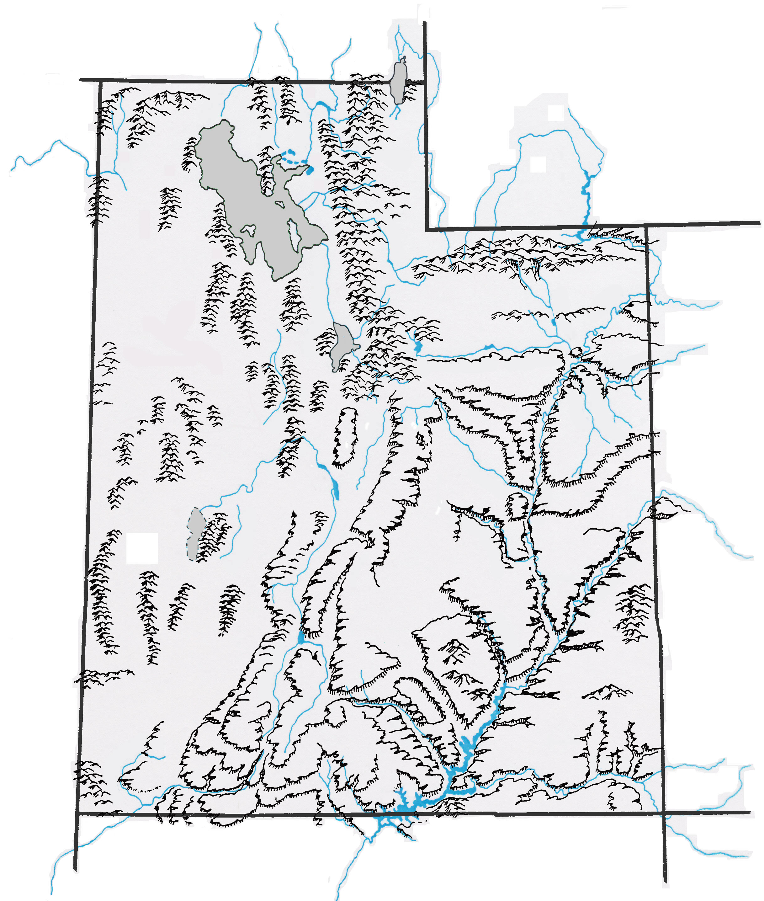Learning where important land forms are in Utah will help you better understand our state and its history. Each unit I will add ~5-10 more places to the map for us to learn. These places will appear on our unit tests . Find these places on this map using pages 25, 9, the big map in class or the internet, label them (write the name next to them). Color the rivers and lakes with blue, shade the mountains with brown, and deserts color in yellow.
Landforms
Great Salt Lake
Utah Lake
Sevier Lake
Lake Powell
Bear Lake

Great Salt Lake Desert
Black Rock Desert

Colorado River
Green River
Jordan River
Sevier River
Santa Clara River
Fremont River
San Juan River
Bear River
Logan River
Ogden River
Weber River
Provo River

Wasatch Mountains
Uintah Mountains
La Sal Mountains
Abajo Mountains
Henry Mountains
Oquirrh Mountains
Tushar Mountains
Book& Roan Cliffs

