Going West: Pioneer Trails Across the U.S.
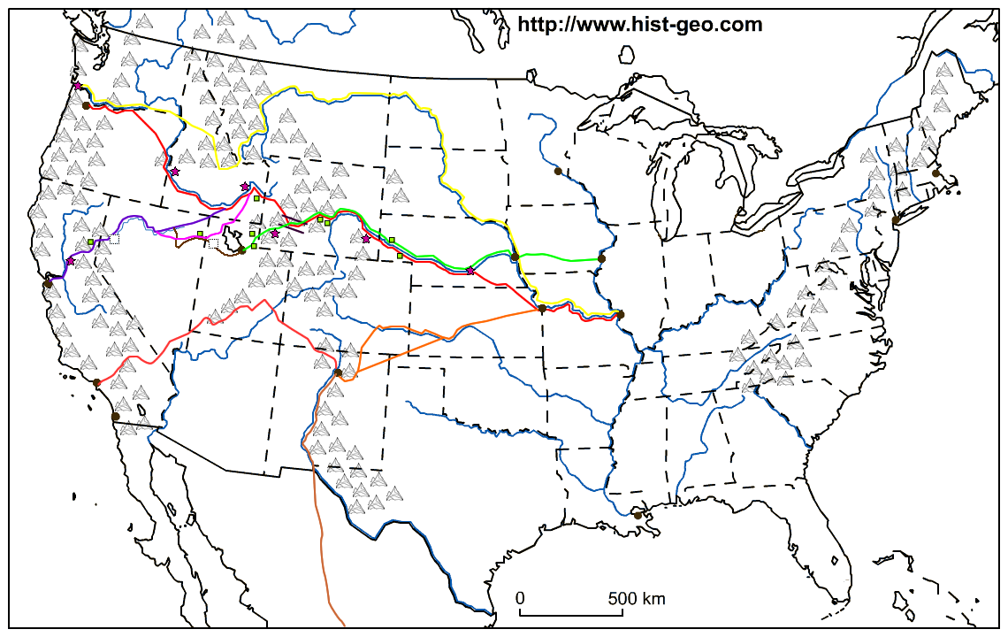
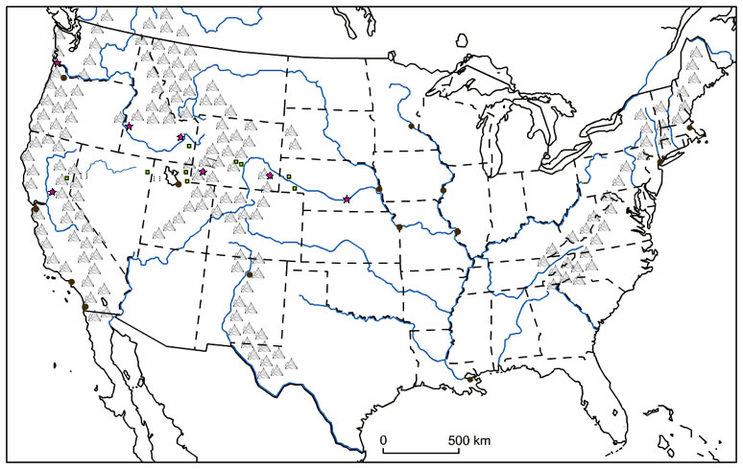
Using the instructions for this map (separate paper) follow the major trails and landmarks pioneers used to travel west.
Key

