Name: ___________________________________ Hour: ________ Date: ____________________________

The Ice Age
Read pages 34, 36-37. Answer the questions using the reading, pictures, maps, etc. on the pages. Then color the map using dark blue for the Great Salt Lake, Utah Lake, and Sevier Lake and light blue for Lake Bonneville. Color the land brown.

1. When did the last ice age take place? (How many years ago?) ___________________________________
2. The ice sheet that covered much of North America did / did not (circle) cover Utah, and created glaciers in the ______________ and ______________ Mountains.
3. When the glaciers melted, they left _____________ filled with water, which are now important for water ____________________ and are also _______________________________ areas.
4. What was the name of Utah’s Ice Age lake? ______________________________ Which modern lakes are remnants of that lake? ______________________, ______________________ & ______________________
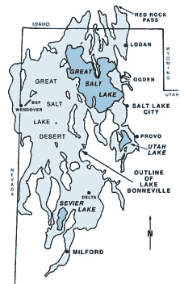
5. The water from that lake (#4) eventually broke through a natural dam at ___________ ____________ Pass. Much of the water was emptied into the ________________ & ___________________ Rivers then flowed to the Pacific.
6. The waves from the lake washed against the sides of mountains until a flat _______________, or terrace, formed.
7. The lake also carried sediments that became some of the best ____________ and gravel deposits in the state.
8. Name six Ice Age animals that lived in Utah.
a) ___________________ b) ___________________
c) ___________________ d) ___________________
e) ___________________ f) ___________________
9. What evidence shows that early people also lived in Utah at this time? _____________________________________
_______________________________________________
10. (From page 34) Salt was left behind as Lake Bonneville evaporated. Utah has enough salt to supply the world for the next __________ years. Most of this salt is used for _____________________ and _____________________.
11. Most of our table salt, however, comes from salt mines in ____________________.
12. Sand and gravel from Lake Bonneville are used today in ___________________, ____________________ & in ___________________.
13. Using the map, which modern cities in Utah would Lake Bonneville have covered? ________________________________________________________________________________________________________________________________________________________________________________

